**Micah Hoffmann**

**Assignment 04**

**7/17/2019**

In this project we will create a DB/Table then via our form button_click, we will open a connection to the database via ASP.NET, and the C# code will then trigger a stored procedure and insert the form data. I will also note that we use the important process of error handling. When we go to open a connection to the database, we use a try/catch code block that will handle and errors that arise during execution.

**Create Database and table to store data**

-Columns must match expected form fields.

-Execute sql query to create table within DB.

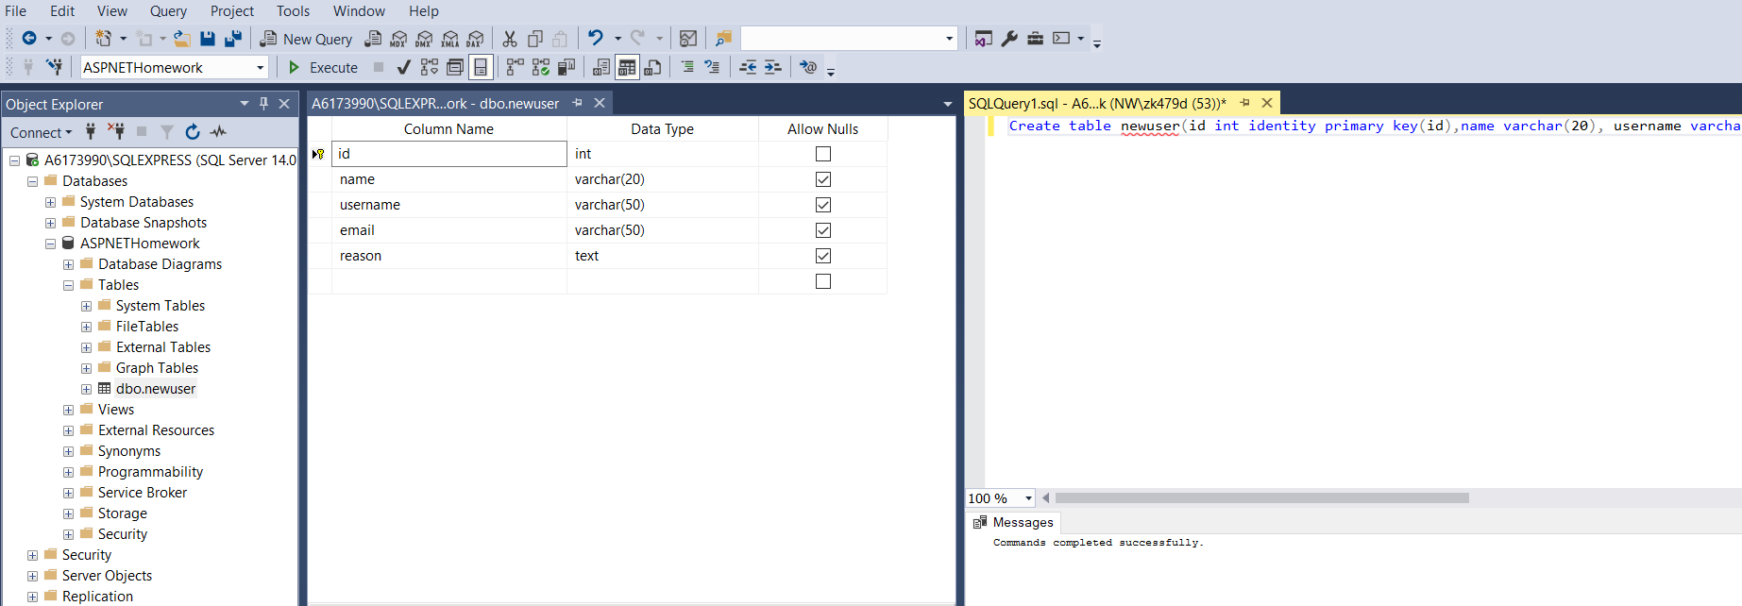

**Design sql query as stored procedure for insert command**

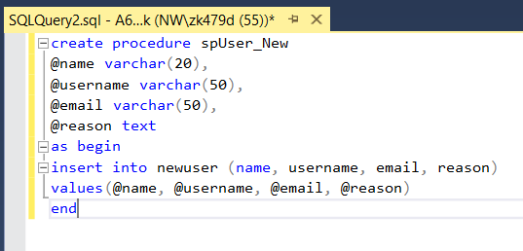

**Build form that will receive the user input.**

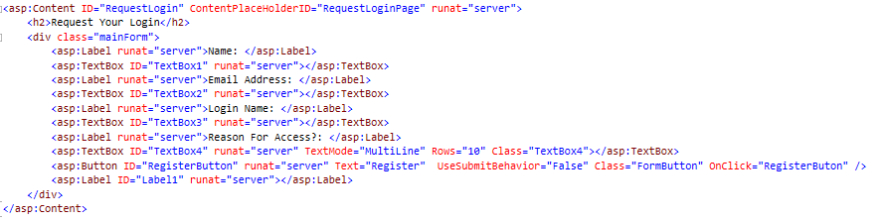

**Configure web.config for connection string**



**Add code behind that handles the button_click**

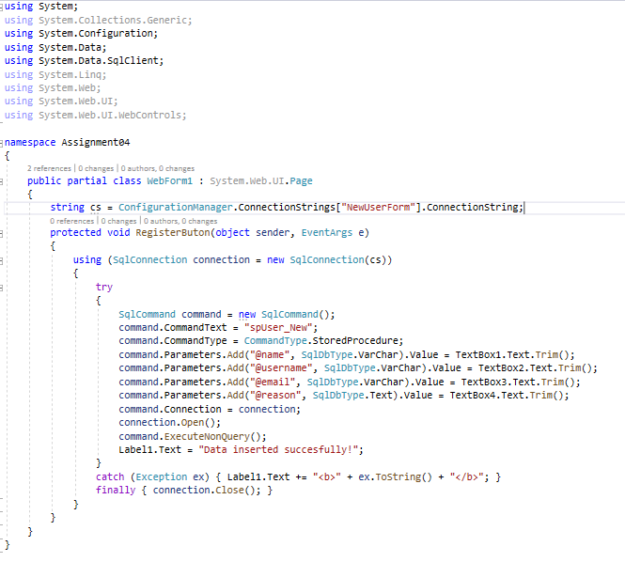

**Exception handling with try/catch**

We can see that the parameter for @reason is spelled wrong when trying to access DB.

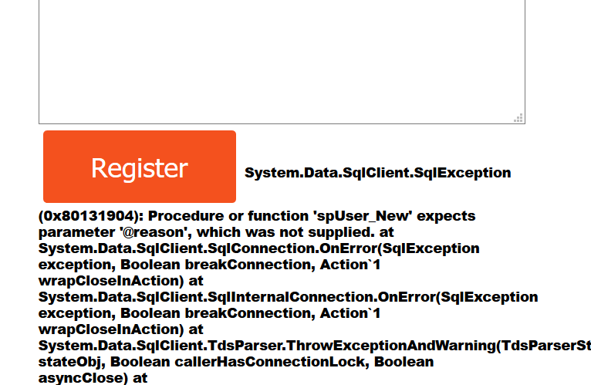

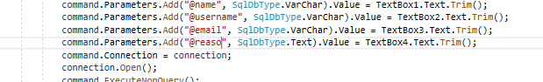

**Finally we can see data was inserted into the table**

